COURSE CODE: PRAC101 Section: BSIT - 4103

COURSE TITLE: OJT / PRACTICUM 1

TERM: 1st Semester, SY 2025-2026

PROFESSOR: MR. VINCENT CARLO T. GARADOS

NAME OF STUDENT: MAHUSAY, CHRISTIAN B.

**OJT NARRATIVE REPORT**

1. TOPIC: FAMILIARIZING WITH AI
2. SPEAKER: MR. MARC TONIDO
3. DURATION: 3:45 PM – 4:45 PM
4. SCREENSHOT OF DUTY

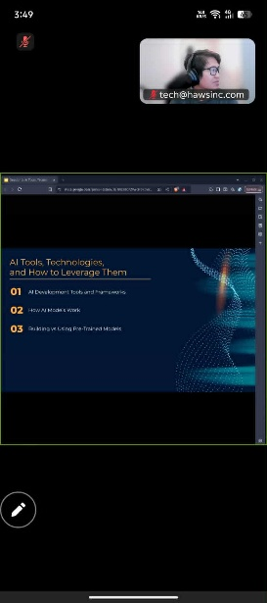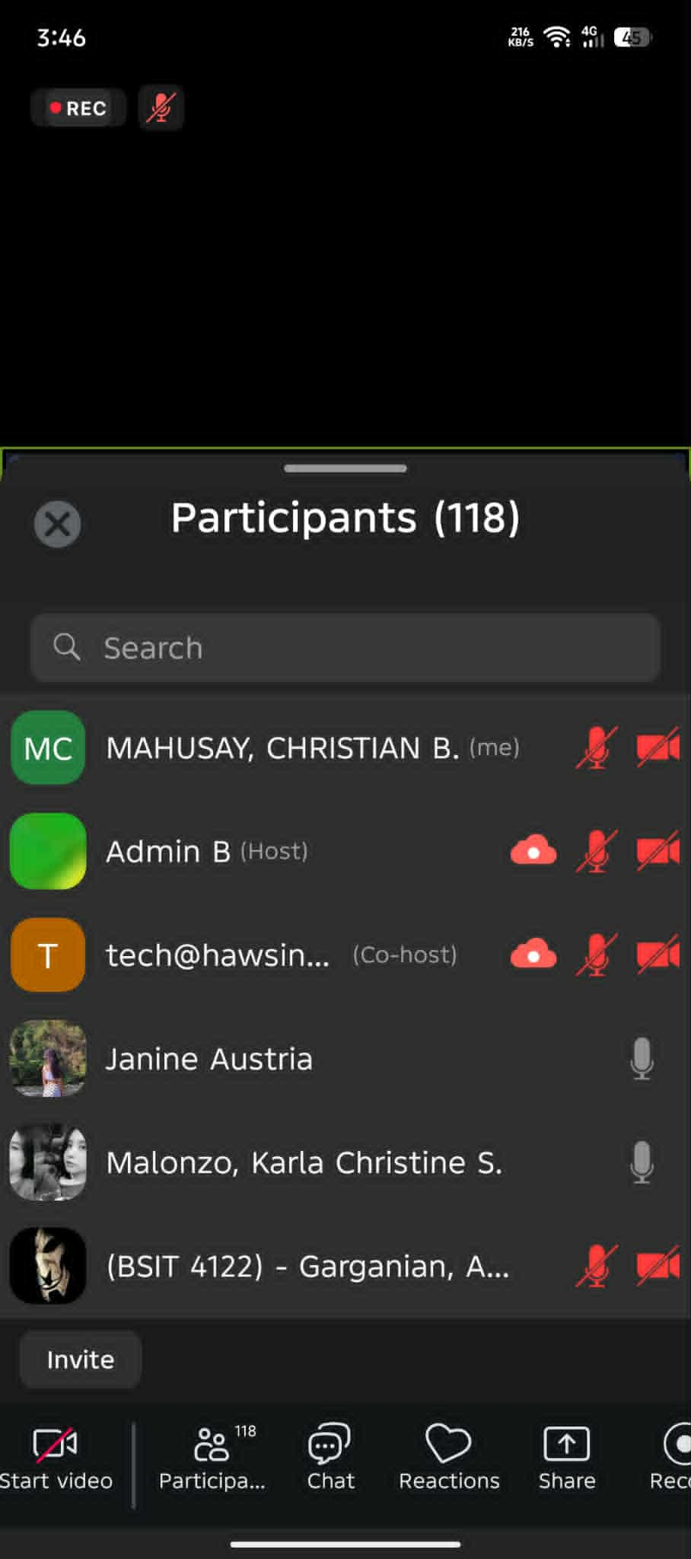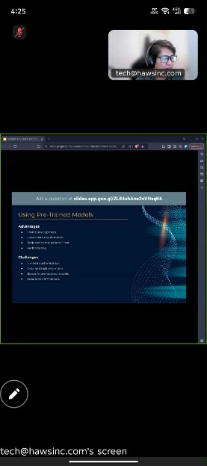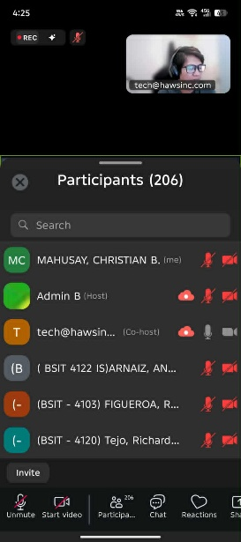

1. REFLECTION

AI TOOLS, TECHNOLOGIES, AND HOW TO LEVERAGE THEM

This session gave me a clearer understanding of the practical side of Artificial Intelligence, especially the tools and frameworks that make AI development possible. I learned how machine learning frameworks such as TensorFlow, PyTorch and Scikit-learn provide the backbone for building and deploying AI models. Each has its own strengths, from TensorFlow’s versatility to PyTorch’s flexibility for research and Scikit-learn’s efficiency for classical ML tasks. This showed me how important it is to choose the right tool for a specific application.

We also explored specialized frameworks for deep learning and natural language processing. Tools like Keras, MXNet and Caffe simplify designing and training neural networks, while spaCy, Hugging Face Transformers and NLTK show how NLP has become more accessible even to non-experts. Understanding these tools helped me see how AI applications such as text analysis, image recognition and predictive modeling are built from the ground up.

Another major takeaway was learning the full cycle of how AI models work, from data preparation and architecture design to training, evaluation, deployment and eventual retraining. This process helped me realize that AI is not just about building a model once but maintaining and improving it continuously as data and requirements evolve.

Finally, I appreciated the discussion on building models from scratch versus using pre-trained models. It made clear the trade-offs between customization and efficiency as well as the importance of balancing innovation with practical constraints like time, cost and data availability. Overall, the session gave me a clearer view of the ecosystem of AI tools and how they can be used responsibly and effectively to create real-world solutions.